**Homework 3**

**CSE 402: Biometrics and Pattern Recognition**

**Instructor: Dr. Arun Ross**

**Due Date: November 21, 2022 (11:00pm)**

**Total Points: 60**

**Note:**

**You are permitted to discuss the following questions with others in the class.**

**However, you *must* write up your *own* answers to these questions. Any indication to the contrary will be considered an act of academic dishonesty.**

**A neatly typed report with detailed answers is expected. The report must be uploaded in D2L in PDF format.**  **All outputs, such as graphs and images, must be included in the report.**

**Any code developed as part of the assignment must be (a) included as an appendix in the report, as well as (b) archived in a single zip file and uploaded in D2L.**

**Include a bibliography at the end of the report indicating the resources that you used (e.g., URL, scientific articles, books, etc.) to complete this homework.**

**Please submit the report (PDF) and the code (Zip file) as two separate files in D2L.**

1. [15 points] Consider a set of 1000 2-dimensional points here. Use Matlab (or any other software) to perform the following tasks:

(a) Compute and report the mean vector of these points.

mean_x =

19.9739

mean_y =

19.9356

(b) Compute and report the covariance matrix of these points.

cov_mat =

9.3989 5.1244

5.1244 10.3847

(c) Compute and report the eigen-vectors and eigen-values of the covariance matrix. There should be two eigen-vectors and two eigen-values.

Eigenvalues: D =

4.7437 0

0 15.0399

Eigenvectors V =

-0.7402 0.6724

0.6724 0.7402

(d) Plot the eigen-vectors (along with the 1000 points) in a 2D graph and display the graph. Note that the eigen-vectors will have to originate from the mean of the points. The length of each vector should be in proportion to its corresponding eigen-value.

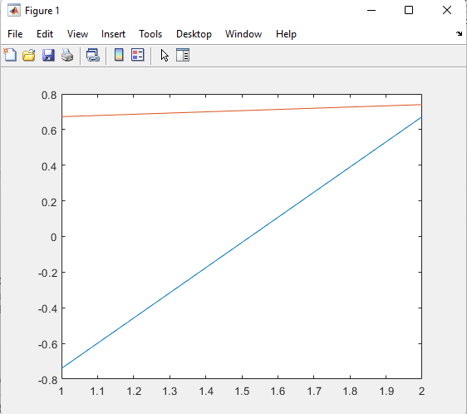

Code:%sharinic - CSE402 - Homework#3 - Question 1

%%[V,D] = eig(A) returns diagonal matrix D of eigenvalues and matrix V

% whose columns are the corresponding right eigenvectors,

% so that A*V = V*D.

text_data = readtable("hw03_pca_data.txt");

points = table2array(text_data);

x = points(:,1);

y = points(:,2);

mean_x = mean(x)

mean_y = mean(y)

cov_mat = cov(x,y)

[V,D] = eig(cov_mat)

plot(x,y);

plot(V);

2. [15 points] One of the *model-based* face recognition methods described in the literature is Elastic Bunch Graph Matching (EBGM). The EBGM technique is discussed in pages 122 - 124 of the textbook. More details about this algorithm can also be found here. In the context of the EBGM algorithm, answer the following questions:

(a) What are fiducial points?

Fiducial points are points of interest or nodes that mark specific areas of the face.

(b) What are Gabor Jets?

Nodes on the graph that are labeled with coefficients that characterizes the local texture information around a landmark location of the face.

(c) What is a Face Bunch Graph (FBG)?

A representation of all faces to cover a variation in the appearance of a face. It should contain fiducial points and jets in different orientations and angles of faces too.

(d) How are two face images compared using the EBGM algorithm?   
 1. Scan the input image and extract the Gabor jets from discrete locations and compare them to the jets in the condensed FBG.

2. Scale the positions and size of the image. Only the FBG jet that is the best match with the image jet is considered.

3. Optimize the graph by manually moving all nodes locally and relative to each other.

(e) What do you think are some of the limitations of the EBGM method for face recognition?

EBGM assumes that the structure of the faces are extremely similar and all possess common features. There could potentially be errors with people who have disfigurements such as missing an ear, eye, or part of the nose.

There are also the manual movements of nodes to gain optimization. These movements are susceptible to operator error.

3. [10 points] Describe the three different levels at which facial characteristics can be organized from a biometrics perspective. Explain the types of features in each level and the role of these features in face recognition.

1. Easily observable features such as skin color and face shape. These can be extracted from low resolution images <30 IPD.
2. Features include the precise shape of the face and its components along with the relation between components. Images are between 30-70 IPD.
3. Micro level features such as scars, freckles, skin discoloration, and moles. These images require high resolution and can be useful in distinguishing twins.

4. [10 points] There are a number of face matching and face analysis applications readily available. For example, Cloud Vision AI, Betaface, PimEyes, Luxand, BioID, Face2Gene, etc.

(a) Experiment with at least two of these applications, and include in your report the input(s) that you gave and the output(s) that was/were produced by each application.

**Betaface**

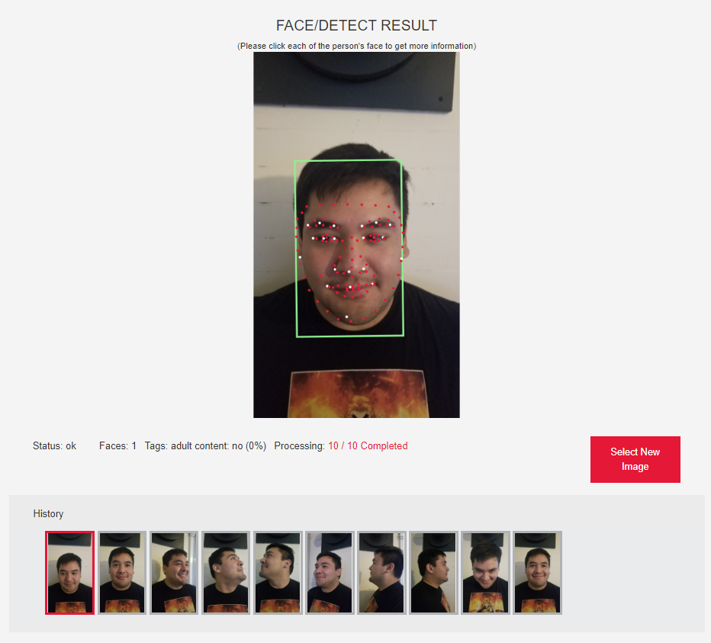

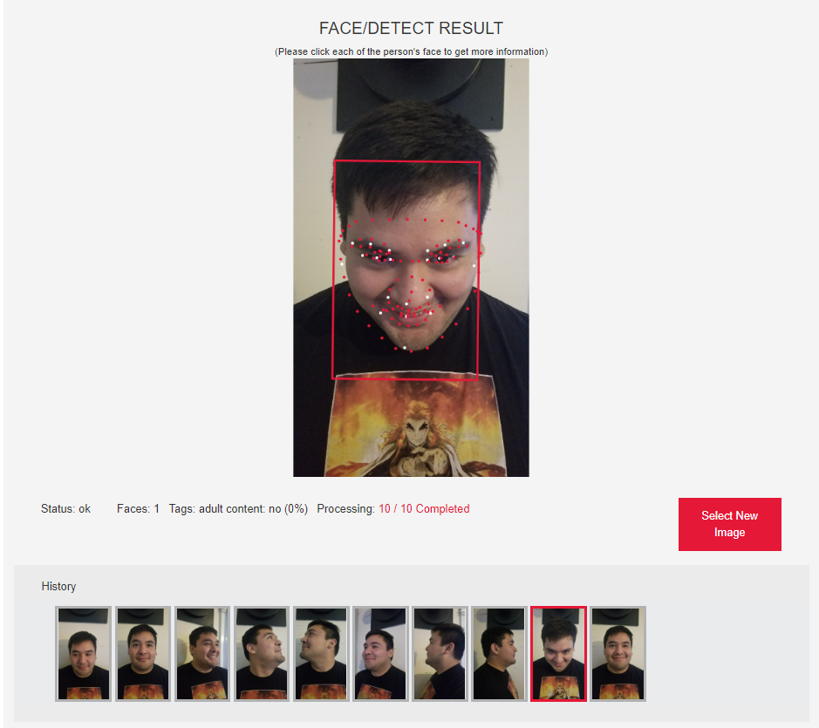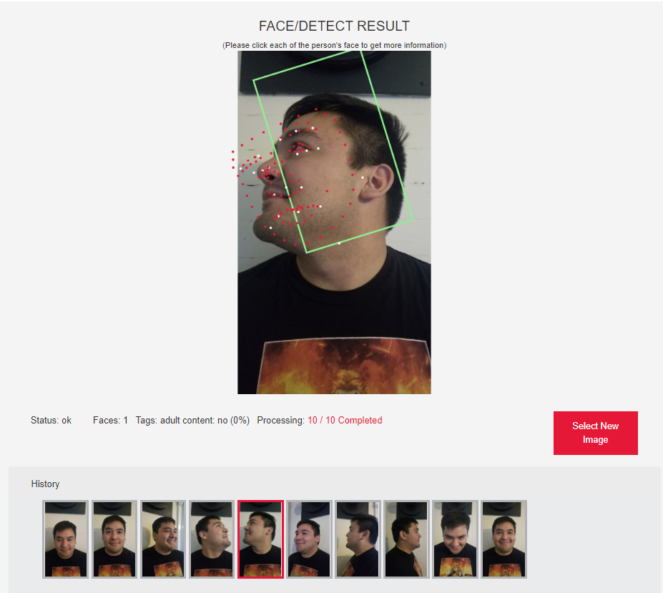

**PimEyes**

Input: 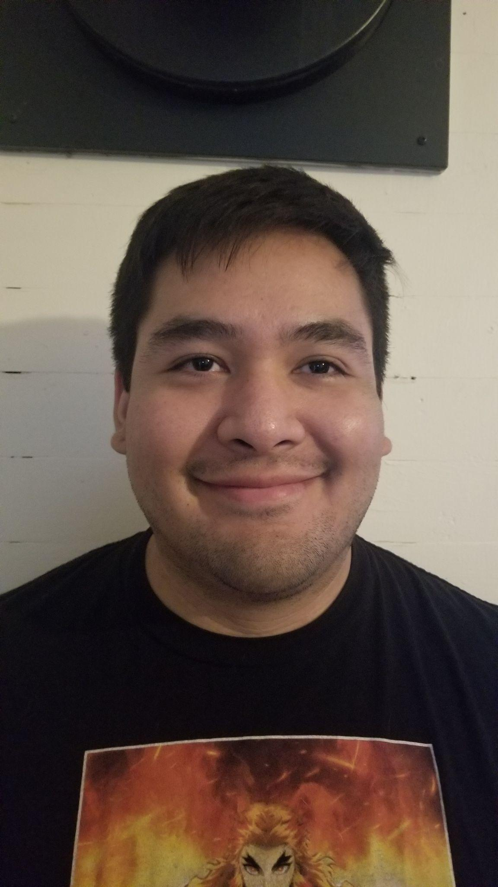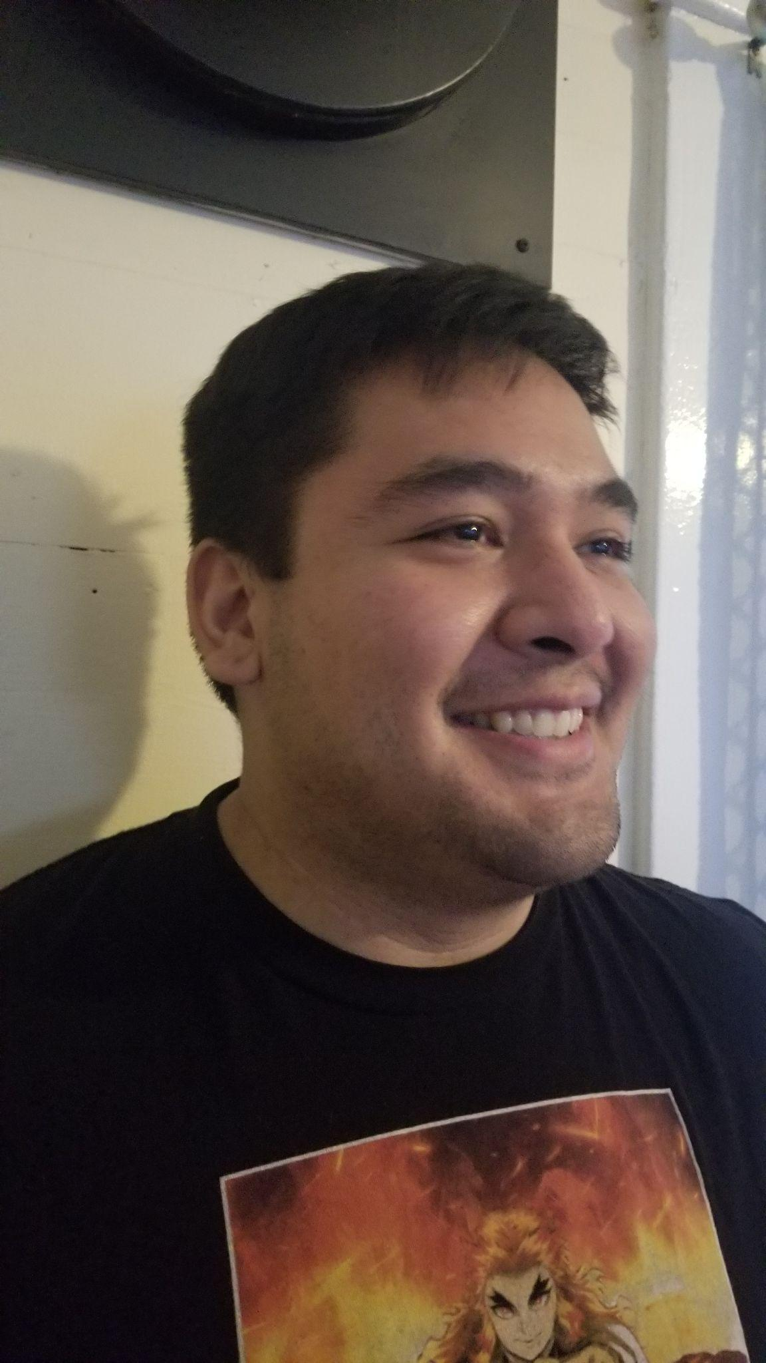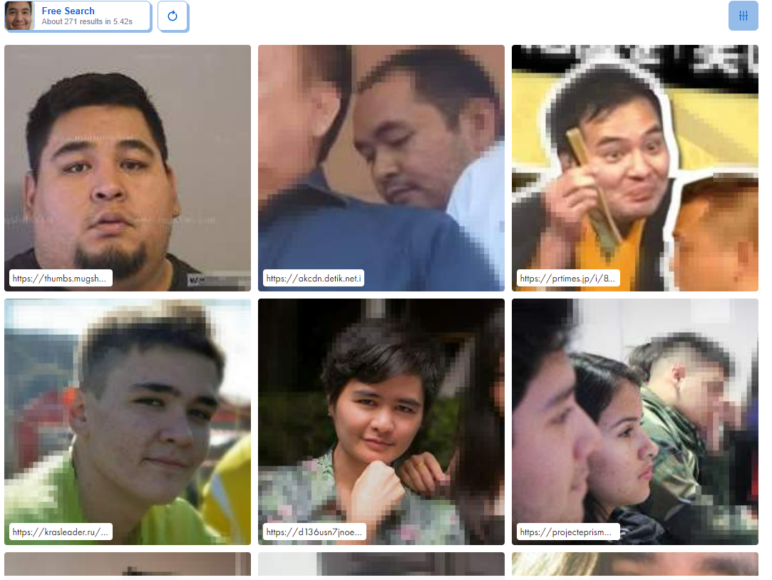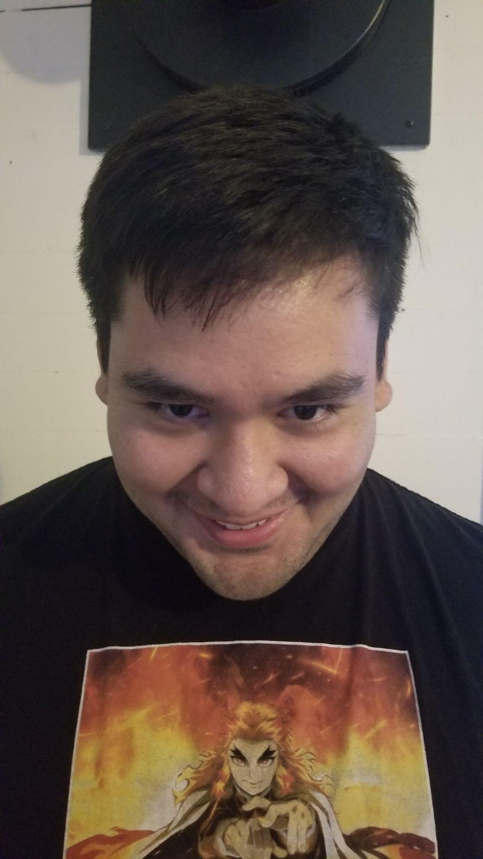

Output:

PimEyes output link.

<https://pimeyes.com/en/results/5AM_p2f3nvBGPVf4fvl?query=01e3cfdfcf0100221d1f090b6f0b0f0faa401ed3937a69b9_07e7c7cfe7000013071f0f0727030f07a5941867467d2de6_c1c1c7df9f00226e1f7f1909ef1d0c0499ae16b13f394a94>

(b) What are the pros and cons of deploying face recognition systems in public spaces? What are some of the ethical aspects of utilizing face recognition in general? Explain your answer in detail. (Note that face *recognition* is different from general face *analytics*).

Pros:

1. Security and law enforcement can track people who are entering and leaving spaces.
2. Businesses could potentially track certain customers and their purchases to distribute targeted advertisements.
3. Employers could automatically identify employees who clock in and out without having the employee interact with a time card system.

Cons:

1. People lose their anonymity when they go into public spaces.
2. Potential for businesses to spam their consumers with ads the way Amazon and Instagram do to their users.
3. Not everyone would agree to be monitored if they knew about it. The system could not be guaranteed to be completely overt.

Ethically, people lose their ability to go about their day in a manner where they have the choice to remain anonymous. The odds of someone recognizing a person who is wearing sunglasses and a hat goes significantly down. However with facial recognition an algorithm would easily be able to identify a person based on other facial features.

5. [10 points] Using the face images that you collected in class, answer the following. You may collect additional selfies of your face, if needed.

(a) Show examples of face images exhibiting different types of intra-class variations. Explain the nature of the intra-class variations. 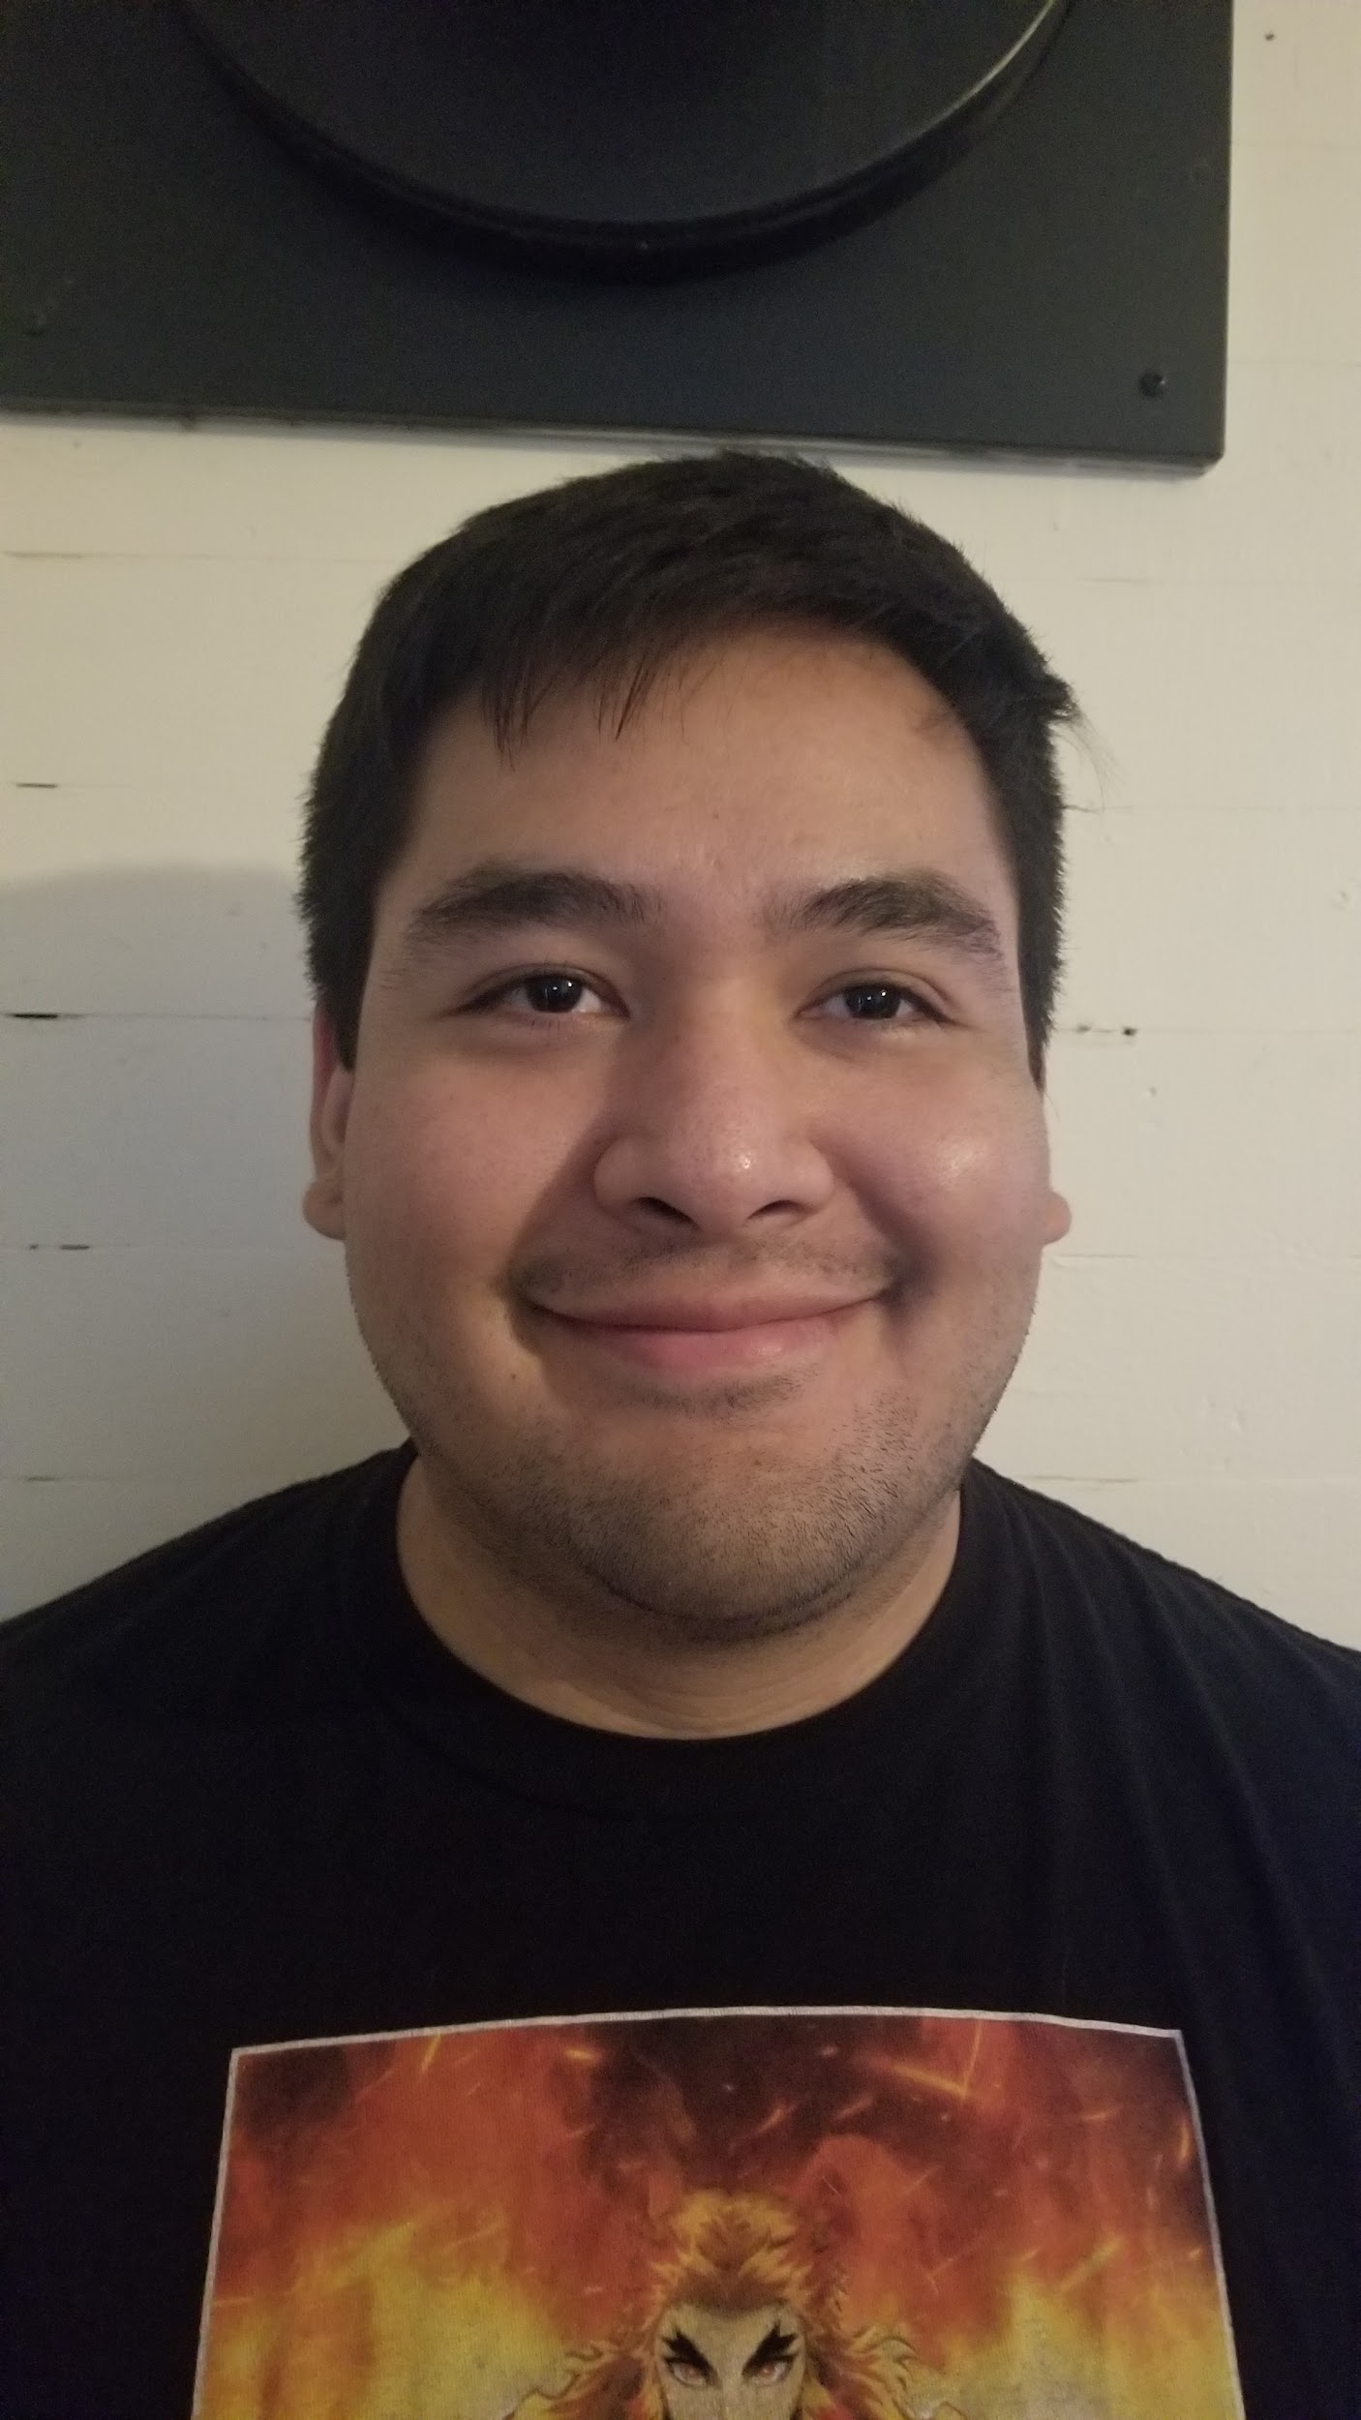

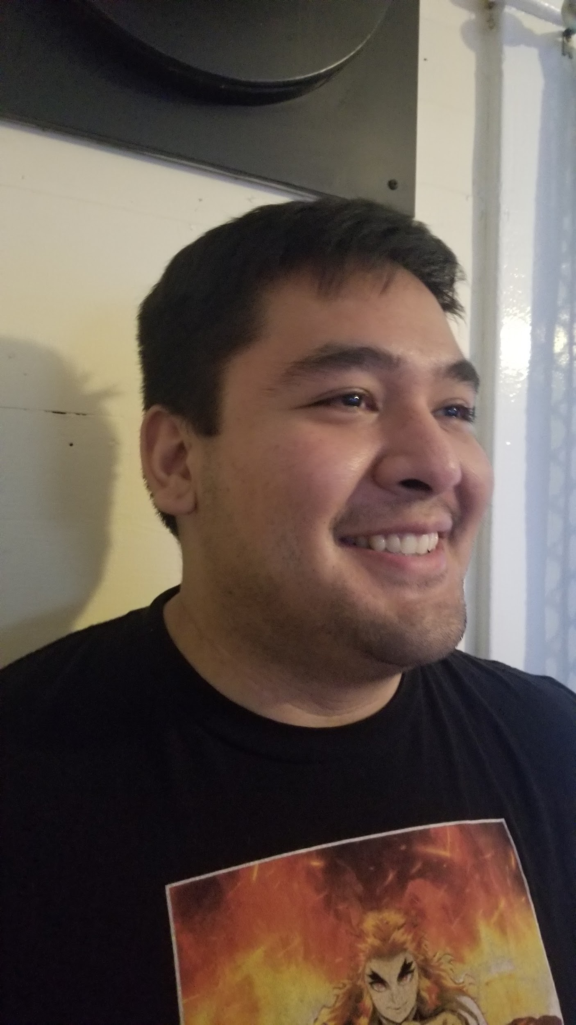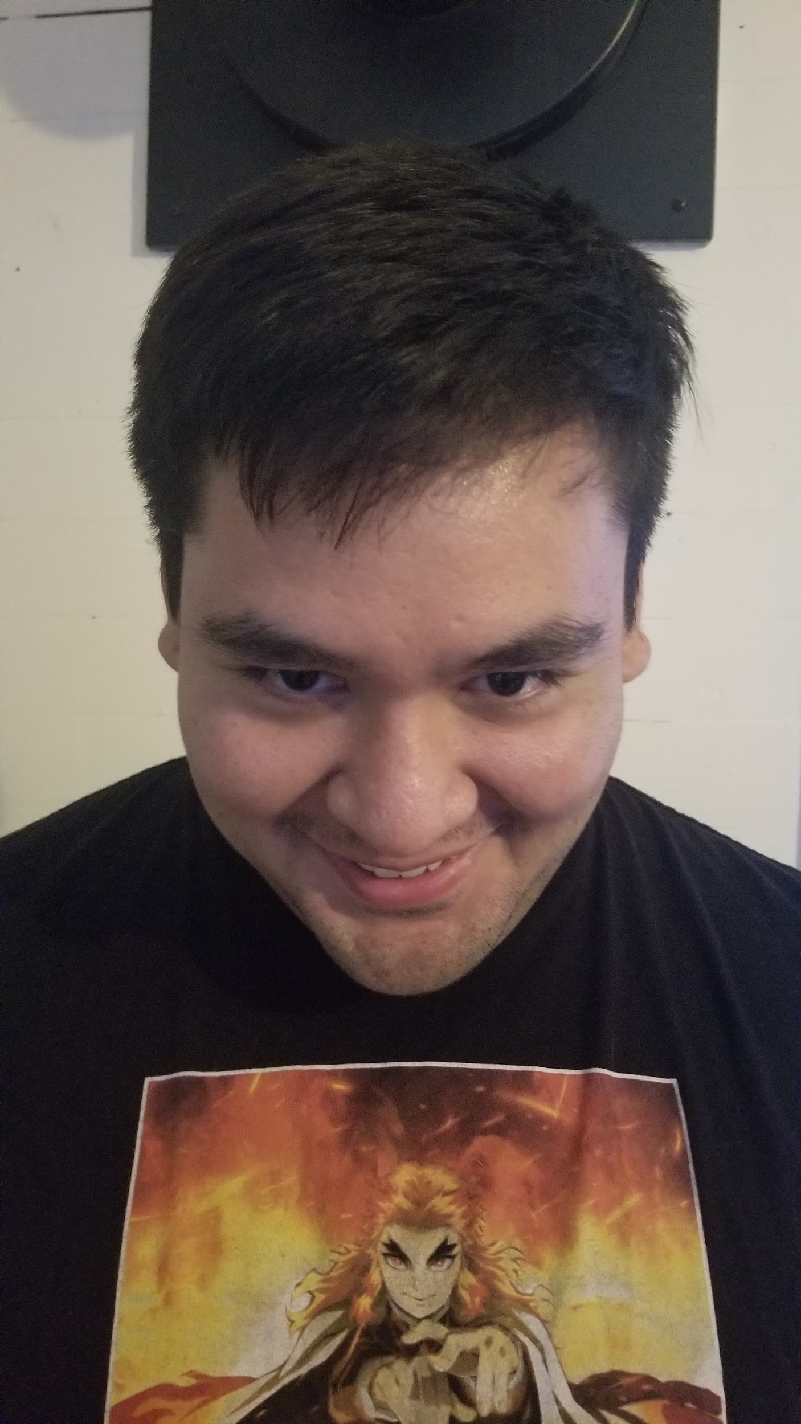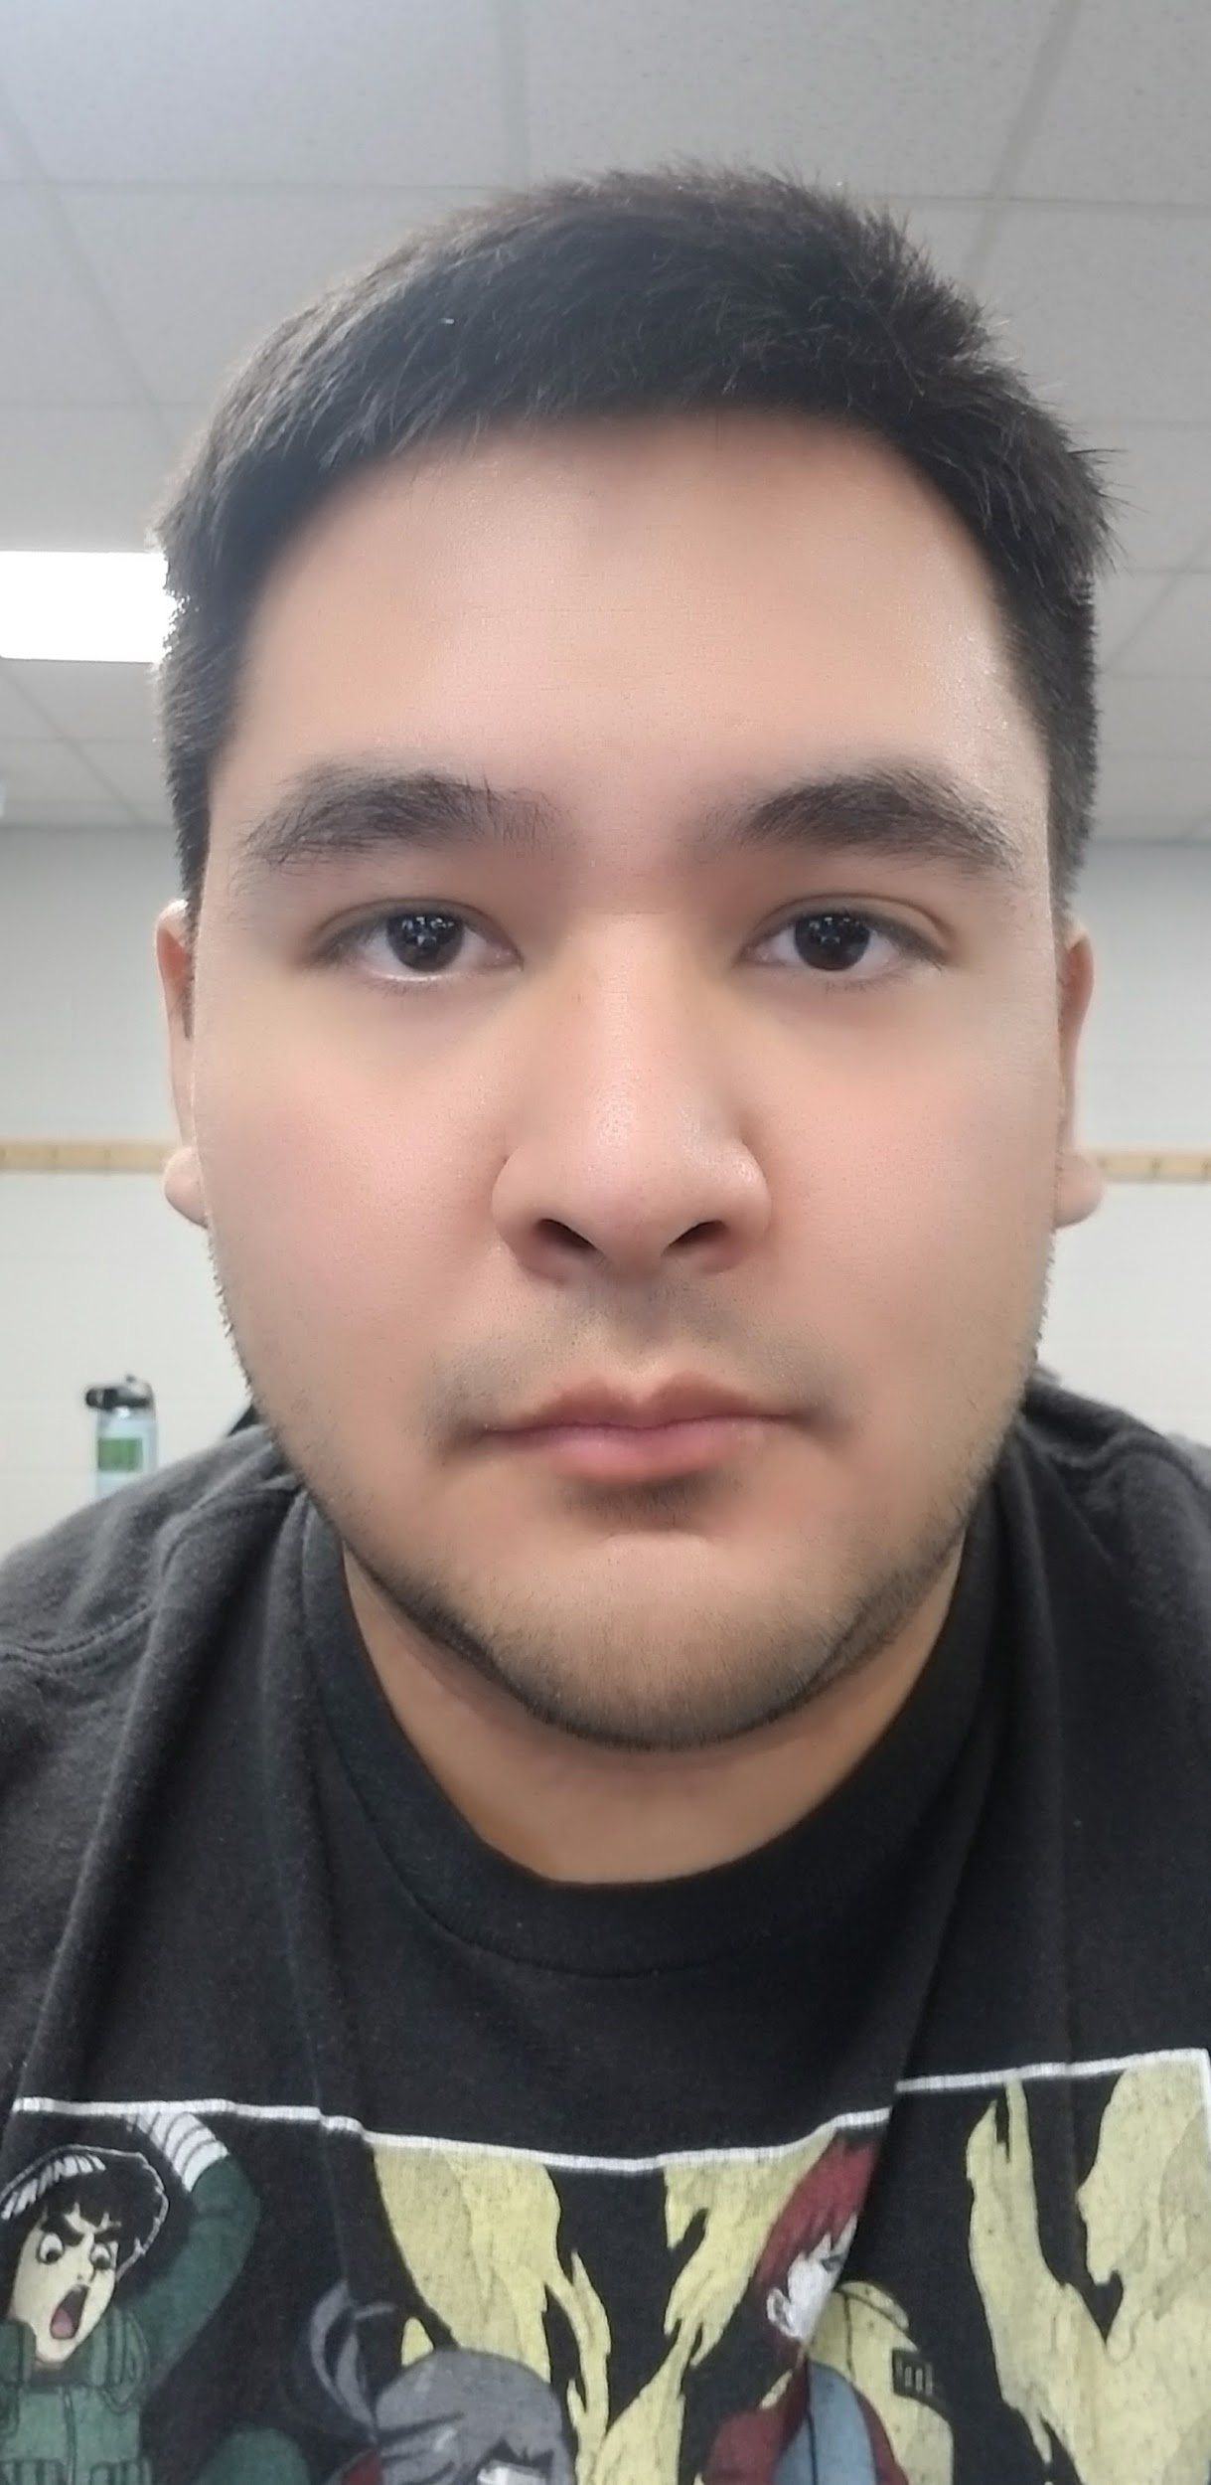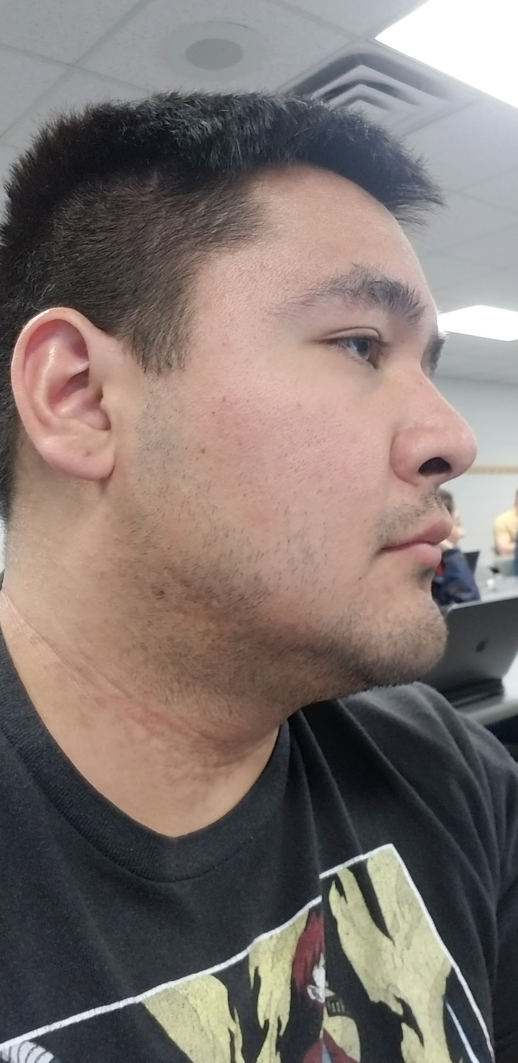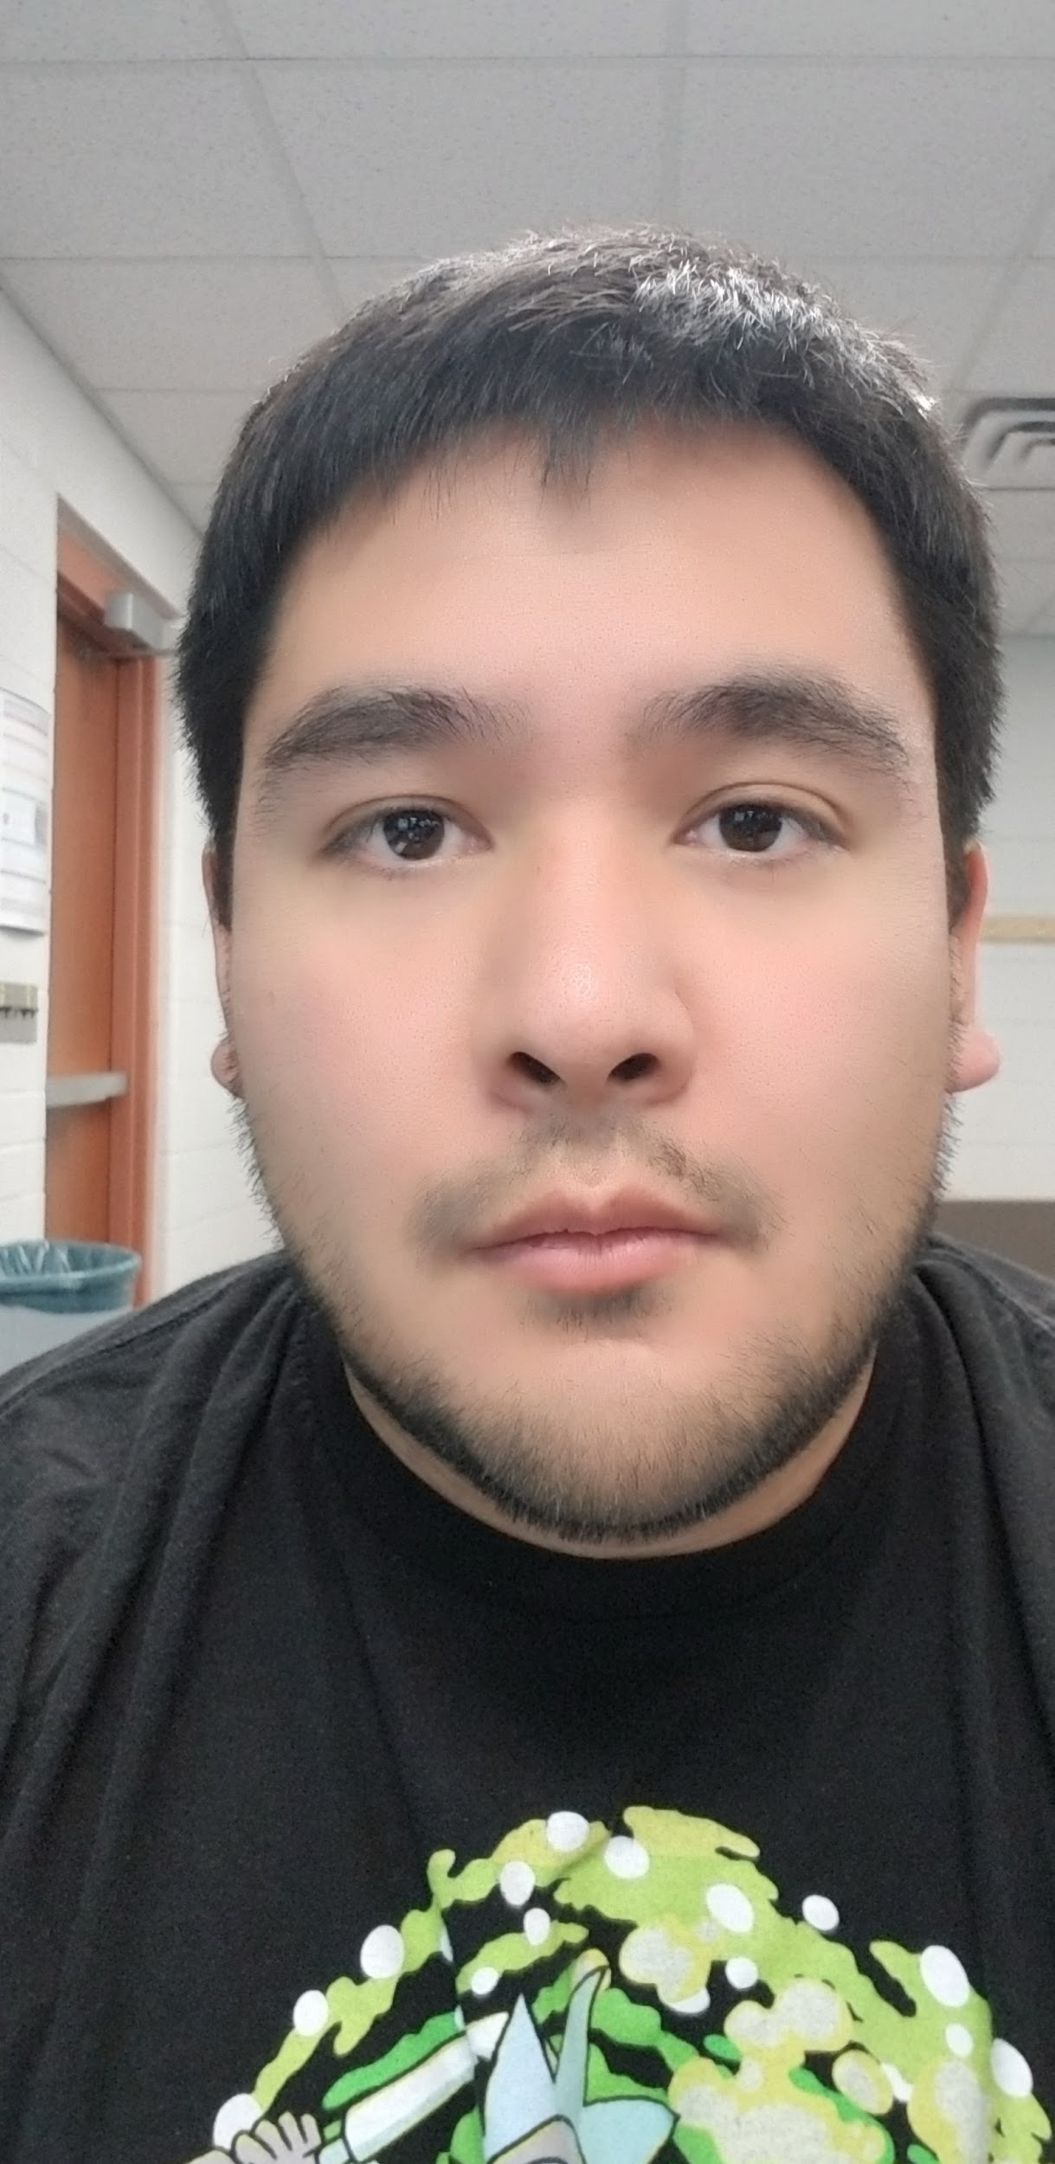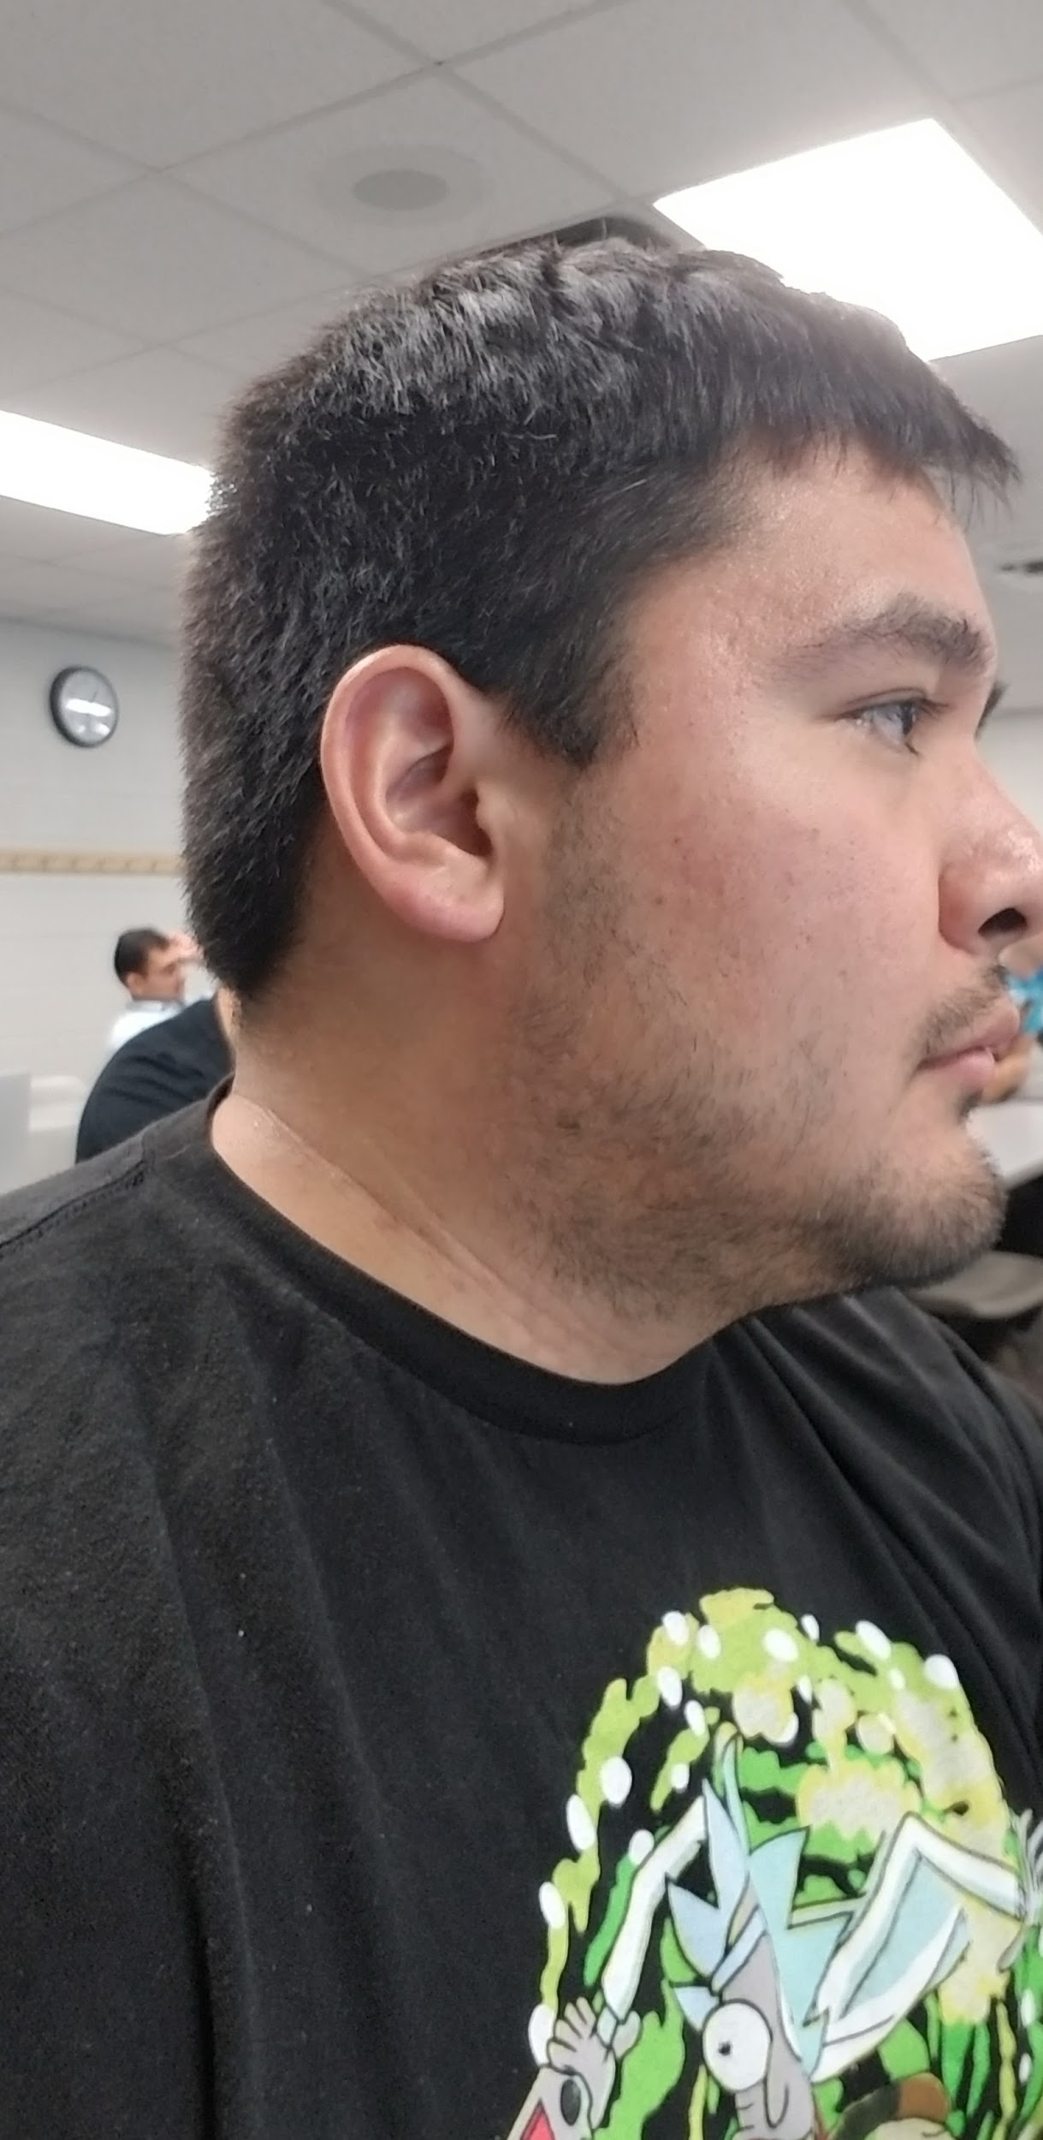

Intra-class variations encompass a wide variety of differences. In the above pictures there are variations in lighting, facial expression, and angle of orientation. One variation not depicted above is a significant change in age since all of the images were taken within the last few months. Other possible variations would include adding accessories to the face such as glasses, a scarf, a hat or earrings.

(b) Which portions of the face are more resilient to changes in expression and why?

Forehead: Despite changing angles, orientation, and facial expression the size of the forehead is nearly unchanged in each image.

Chin: The relative distance from the bottom lip to the bottom of the chin is almost the same in different lighting, with different facial expressions, and using a side profile.

Distance Between the Eyes: In all front-facing images the distance between the eyes remains the same even while changing angle, lighting, and expression.

(c) Take one of the frontal face images, convert it to grayscale and convolve the grayscale image with **average filters** of the following dimensions: 3 × 3, 15 × 15, 45 × 45. Show the input image and the output images. Explain the differences in output pertaining to the 3 filters.

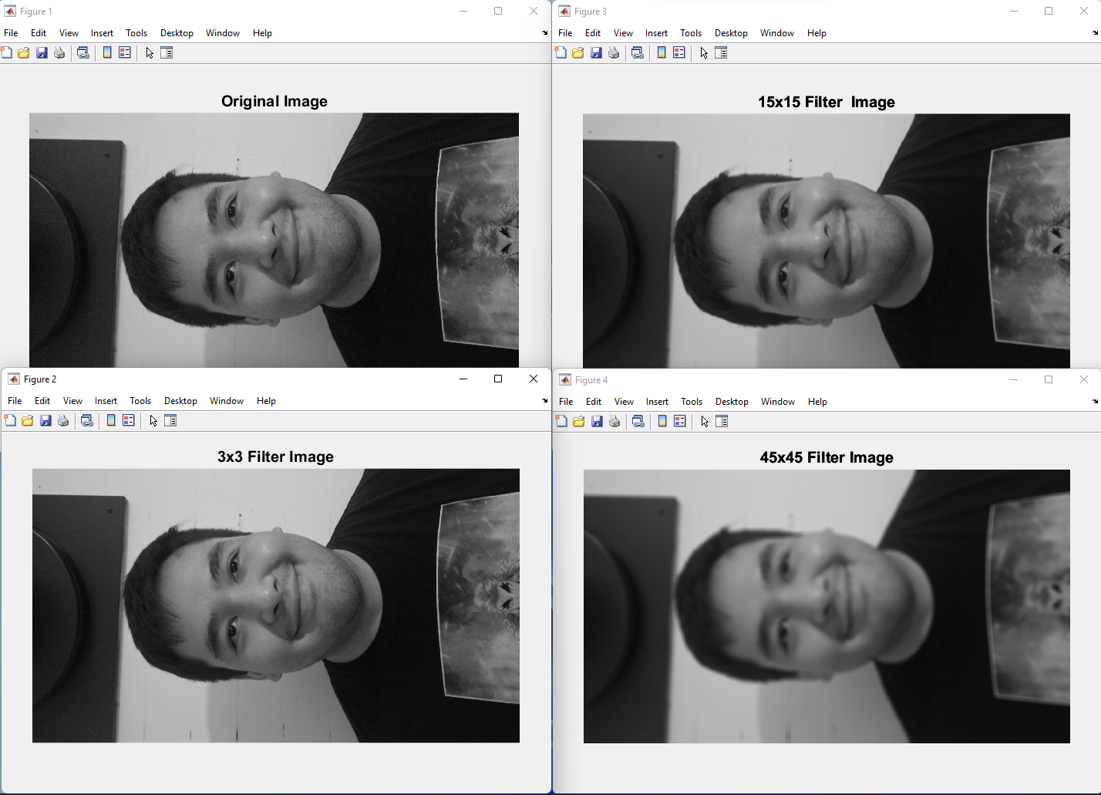

Matlab Code

%CSE402 - Homework 3 Question 5

face_color = imread('myfacefront.jpg');

face_gray = rgb2gray(face_color);

%face_gray = double(face_gray);

imshow(face_gray)

title('Original Image', 'FontSize', 15);

figure

kernel3 = ones(3,3)/9;

avg_filter3 = imfilter(face_gray, kernel3, "symmetric");

imshow(avg_filter3)

title('3x3 Filter Image', 'FontSize', 15);

figure

kernel15 = ones(15,15)/225;

avg_filter15 = imfilter(face_gray, kernel15, "symmetric");

imshow(avg_filter15)

title('15x15 Filter Image', 'FontSize', 15);

figure

kernel45 = ones(45,45)/2025;

avg_filter45 = imfilter(face_gray, kernel45, "symmetric");

imshow(avg_filter45)

title('45x45 Filter Image', 'FontSize', 15);

(d) From your perspective, what are some of the challenges in performing face recognition using selfies.

The original quality of the selfie affects the ability to perform facial recognition. People also take selfies differently. Some people take them at different distances from their face and at different angles.